|  |
| --- |
| **D:\CE\WhatsApp Image 2021-05-08 at 4.35.03 PM.jpeg**    **“Cultivating excellence in every student”**    **RAKESH KUMAR**  **M.Sc. (Chemistry) B.Ed.**  **CTET, PSTET, HPTET qualified**  thakurkumar82@gmail.comA taste of technology | News Centre - Official news site of Calderdale  Councilhttp://chemistryexpert.in/ |
| **Class:-XII (Sci.) Name of Student……………………**  **Subject:- Chemistry**  **10 year QuStions**  **Chapter-13 (Amines)** |

1. Account for the following, supporting your answer with diagrams or equations wherever possible: (a) Diazonium salts of aromatic amines are more stable than those of aliphatic amines. (b) Methylamine in water reacts with ferric chloride to precipitate hydrated ferric oxide.

2. Arrange the following in decreasing order of pkb giving reason:

(a) Aniline, p-nitro aniline and p-toluidine (b) C2H5NH2 , (C2H5 )2NH, (C2H5 )3N in gaseous state.

3. Write the reaction involved in the Hoffmann bromamide degradation reaction.

4. Propanamine and N, N-dimethylmethanamine contains the same number of carbon atoms, even though Propanamine has higher boiling point than N, N-dimethylmethanamine. Why?

5. (a) Give one chemical test to distinguish between the compounds of the following pairs : (i) CH3NH2 and (CH3 )2NH (ii) Aniline and Ethanamine (b) Why aniline does not undergo Friedel-Crafts reaction ?

6. (a) Gabriel phthalimide synthesis is not preferred for preparing aromatic primary amines. (b) On reaction with benzene sulphonyl chloride, primary amine yields product soluble in alkali whereas secondary amine yields product insoluble in alkali.

7. 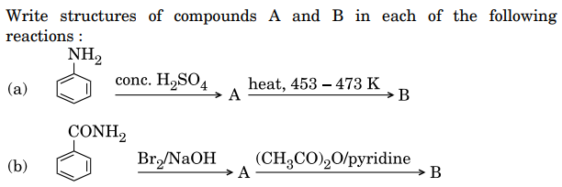

8. How do you convert the following: (a) N-phenylethanamide to p-bromoaniline?

(b) Benzene diazonium chloride to nitrobenzene (c) Benzoic acid to aniline

9. 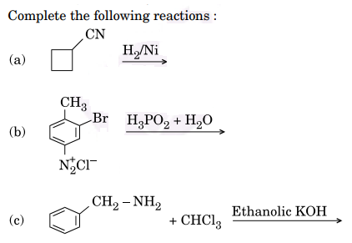

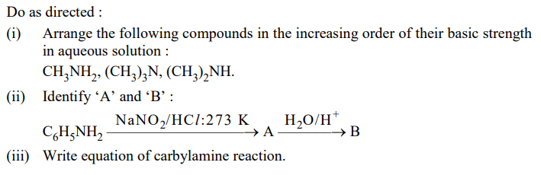10. An aromatic compound ‘A’ on heating with Br2 and KOH forms a compound ‘B’ of molecular formula C6H7N which on reacting with CHC*l*3 and alcoholic KOH produces a foul smelling compound ‘C’. Write the structures and IUPAC names of compounds A, B and C.

11.

12. (a) Write the structures of the main products when benzene diazonium chloride reacts with the following reagents : (i) CuCN (ii) CH3CH2OH (iii) Cu / HC*l* (b) Arrange the following in the increasing order of their basic strength : CH3NH2 , (CH3 )2NH, C6H5NH2 , C6H5CH2NH2 (c) Write one chemical test to distinguish between Aniline and Ethyl amine.

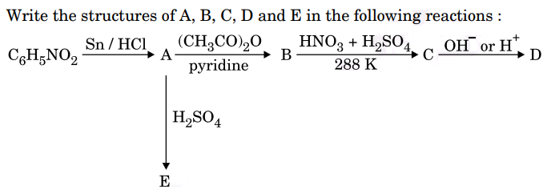13.

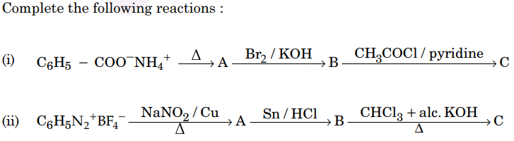14.

15. 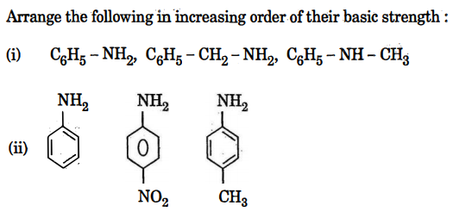

16. How do you convert the following : (i) C6H5 CONH2 to C6H5NH2 . (ii) Aniline to phenol (iii) Ethanenitrile to ethanamine .

17. Write the chemical· equations involved when aniline is: treated with· the following reagents. (i) Br2 water (ii) CHC*1*3 + KOH (iii) HC*l*

18. giving an example for each, describe the following reactions: (i) Hofmann’s bromamide reaction (ii) Gatterman reaction (iii) A coupling reaction.

19. How are the following conversions carried out: (i) Aniline to nitrobenzene (ii) Ethanamine to N-ethylethanamide (iii) Chloroethane to propan-1-amine?

20. Give one chemical test each to distinguish between the compounds in the following pairs: (i) Methylamine and dimethylamine (ii) Aniline and benzylamine (iii) Ethylamine and aniline.

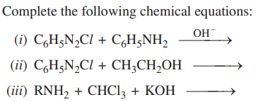21. In the following cases rearrange the compounds as directed: (i) In an increasing order of basic strength: C6H5NH2, C6H5N (CH3)2, (C2H5)2 NH and CH3NH2 (ii) In a decreasing order of basic strength: Aniline, p-nitro aniline and p-toluidine (iii) In an increasing order of pKb values: C2H5NH2, C6H5NHCH3, (C2H5)2NH and C6H5NH2.

22.

23. Give the chemical tests to distinguish between the following pairs of compounds: (i) Methylamine and Dimethylamine (ii) Aniline and N-methylaniline.

24. (a) Explain why an alkylamine is more basic than ammonia. (b) How would you convert (i) Aniline to nitrobenzene (ii) Aniline to iodobenzene?

25. State reasons for the following: (i) pKb value for aniline is more than that for methylamine. (ii) Ethylamine is soluble in water whereas aniline is not soluble in water. (iii) Primary amines have higher boiling points than tertiary amines.

26. Write chemical equations for the following conversions: (i) Nitrobenzene to benzoic acid (ii) Benzyl chloride to 2-phenylethanamine (iii) Aniline to benzyl alcohol.

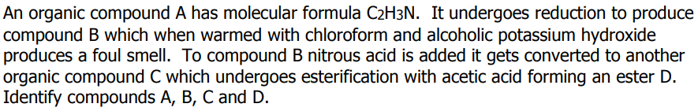27. (a) Give a possible explanation for each one of the following: (i) There are two —NH2 groups in semicarbazide. However, only one such group is involved in the formation of semicarbazones. (ii) Cyclohexanone forms cyanohydrin in good yield but 2, 4, 6-trimethylcyclohexanone does not. (b) An organic compound with molecular formula C9H10O forms 2, 4-DNP derivative, reduces Tollen’s reagent and undergoes Cannizzaro’s reaction. On vigorous oxidation it gives 1,2-benzene-di-carboxylic acid. Identify the compound.

28.

**,………………………**